Colorado Athletic Trainers’ Association (CATA)
Awards and Scholarships Manual

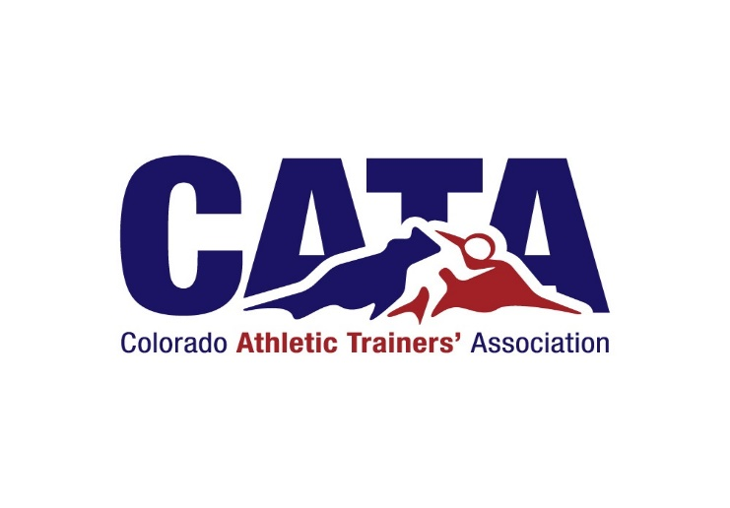

CATA Honors and Awards Committee
Email: coatahonorsandawards@gmail.com
Website: www.coloradoata.org
Revised 2025

Table of Contents
- Introduction
- Overview
- Purpose
- Committee Responsibilities
- Membership and Composition
- Key Dates and Procedures
- Voting and Evaluation
- Nomination Eligibility
- General Nomination Requirements
- CATA Honors and Awards
- Scholarships

Introduction
This manual serves as a comprehensive guide for all Colorado Athletic Trainers’ Association (CATA) awards and scholarships. It outlines eligibility, nomination procedures, criteria, and presentation details for each award, ensuring fairness, transparency, and consistency in recognizing the outstanding members and supporters of athletic training in Colorado.

Overview
The Colorado Athletic Trainers’ Association (CATA) Honors and Awards (HAA) Committee recognizes individuals who demonstrate exceptional service, leadership, and dedication to the athletic training profession. Through its various awards and scholarships, the Committee celebrates those who have made outstanding contributions to the advancement of athletic training in Colorado and beyond.

Purpose
The Honors and Awards Committee (HAA) is responsible for evaluating all award and scholarship nominations, recommending deserving recipients to the Colorado Athletic Trainers’ Association (CATA) Board of Directors (BOD), and coordinating the annual recognition and award presentations. The Committee ensures that the selection process reflects fairness, transparency, and the values of service, leadership, and excellence upheld by the CATA.

Committee Responsibilities
- Recommend award criteria and recipients to the CATA Board of Directors.
- Secure and prepare plaques and other award materials within board guidelines.
- Ensure all awards include the official CATA seal.
- Present awards at the annual CATA meeting or symposium.
- Advise the BOD on award-related matters.

Membership and Composition
The HAA Committee consists of a Chair and appointed members per CATA policy. Members are responsible for collecting, reviewing, and scoring all nominations and scholarship applications. Committee members are not eligible for awards while serving on the committee.

Key Dates and Procedures
- Nomination Period: January 1 – April 14, 2026
- Submission Deadline: April 14, 2026 (11:59 PM)
- Board Review: Approximately May 1, 2026
- Award Notification: Within seven (7) days of BOD approval

Voting and Evaluation
Each nominee is evaluated using standardized award rubrics. The nominee(s) who best meet the criteria are recommended to the Board for approval. In the event of a tie, multiple recipients may be selected. Awards may be withheld if no qualified nominations are received.

Nomination Eligibility
Who May Nominate:
- Any current CATA member in good standing may submit a nomination for eligible candidates.
- Students may recommend qualified individuals to a certified CATA member, who must submit the official nomination form.
- Administrators or faculty from secondary schools, colleges, or universities may also nominate individuals for education-related awards.

General Nomination Requirements (Applies to All Awards)
Unless otherwise noted within individual award descriptions, each nomination submission must include the following:
- Completed online nomination form (available at www.coloradoata.org) submitted by the published deadline.
- Résumé or Curriculum Vitae (CV) outlining the nominee’s education, credentials, professional experience, and service to the profession.
- Statement of justification summarizing the nominee’s qualifications, achievements, and impact on the profession or Colorado AT community.
- Two (2) letters of recommendation supporting the nominee’s qualifications and contributions (one must be from a certified athletic trainer, supervisor, or professional colleague).
- Verification of good standing with the Board of Certification (BOC), if applicable. (HAH committee will verify)
- Supporting documentation as required by specific awards (e.g., teaching excellence, scholarly work, or lifesaving documentation).
Incomplete or late submissions will not be considered at the discretion of the Honors and Awards Committee.

CATA Honors and Awards

Hall of Fame Award
Honors long-standing CATA members who have made exceptional, enduring contributions to both the athletic training profession and the Association. Recipients exemplify a career of service, leadership, and professional excellence that has significantly advanced the field and inspired future generations of athletic trainers.
Eligibility and Criteria:
- Certified athletic trainer and CATA member in good standing for a minimum of 20 years.
- Demonstrated exceptional and sustained contributions to the profession and Association.
- Record of leadership, mentorship, and professional excellence influencing the field.
- Eligible for posthumous or special consideration for extraordinary contributions.
Additional Required Materials: Consideration Letter (if applicable).

Athletic Training Service Award
Recognizes CATA members who have provided outstanding service to the profession, their community, and the Association. Recipients demonstrate sustained dedication, professional involvement, and a commitment to advancing athletic training in Colorado.
Eligibility and Criteria:
- Certified athletic trainer and CATA member for at least 10 years.
- Sustained service and professional involvement that advances athletic training in Colorado.
- Evidence of volunteerism, advocacy, or committee work related to athletic training is strongly encouraged.
Additional Required Materials: One letter of recommendation from an allied health professional, physician, or athletic trainer.

Robert Ryan Educator Award
Named in honor of Robert Ryan, ATC, this award recognizes excellence in teaching, mentorship, and leadership in athletic training education.
Eligibility and Criteria:
- Active NATA/CATA membership for at least five years.
- Minimum of five years as an educator, mentor, or preceptor.
- Evidence of teaching excellence, scholarly work, or professional presentations required.
Additional Required Materials: Evidence of teaching excellence, scholarly contributions, or professional presentations.

Distinguished Athletic Trainer Award
Honors Certified Athletic Trainers who exemplify exceptional professionalism, clinical excellence, and leadership within their respective practice settings.
Eligibility and Criteria:
- Current CATA member in good standing with the BOC (or retired in good standing).
- Minimum of five years of professional experience.
- Demonstrated excellence in one or more of the following: clinical expertise, leadership, mentorship, or advocacy.
Additional Required Materials: Statement of justification and two letters of recommendation highlighting leadership, service, and impact.

CATA Honorary Membership Award
Recognizes individuals or organizations that have made outstanding and lasting contributions to the advancement of athletic training and sports medicine in Colorado.
Eligibility and Criteria:
- May be awarded to non–athletic trainers or professionals from related fields.
- Nominees must have significantly promoted or supported the profession within Colorado.
Additional Required Materials: Summary or documentation of contributions to athletic training or sports medicine in Colorado.

Life Saver Award
Honors a Certified Athletic Trainer or student whose actions directly resulted in saving a life.
Eligibility and Criteria:
- Nominee must be a Certified Athletic Trainer or student in good standing.
- Lifesaving event must be documented and verified with supporting materials.
Additional Required Materials: Description and documentation (e.g., media report or written statement) of the lifesaving event.

Scholarships
CATA offers two major scholarships to support future athletic trainers in Colorado. These awards honor the legacies of Dan Libera and Jim Conboy, both of whom made remarkable contributions to athletic training education.

Dan Libera Athletic Training Scholarship
Awarded to a student accepted into a professional athletic training program in Colorado. Named in honor of Dan Libera, a national leader in athletic training education at the University of Northern Colorado (1971–1997).

Jim Conboy Athletic Training Scholarship
Awarded to a student currently enrolled in a Colorado professional athletic training program with at least one year remaining. Named for Jim Conboy, longtime athletic trainer at the U.S. Air Force Academy and NATA Hall of Fame member.

Scholarship Criteria
- Current NATA student membership.
- Strong academic performance and professionalism.
- Demonstrated excellence in athletic training duties, leadership, and community service.

Application Requirements
- Online application form.
- One-page essay on career goals and motivation in athletic training.
- One letter of recommendation from a certified athletic trainer.
- One letter from a program director, clinical education coordinator, or school representative.
- Unofficial transcript.
- Deadline: April 14, 2026
- Funds are distributed for the following academic year.

Selection Process
- Applications are scored using standardized criteria.
- Top applicant(s) selected and notified by the HAA Chair.
- Chair confirms contact details and informs the CATA President and Treasurer.

