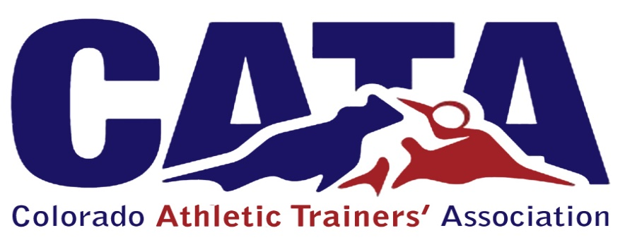

Students
Chair: as appointed
Members: as many deemed necessary
- The purpose of the Student Committee is as follows:
  - To bring unity to the students of Athletic Training across the state of Colorado
  - To provide Athletic Training Students an opportunity to experience leadership roles with in the Athletic Training Profession
  - To provide a forum to allow Athletic Training students to be proactive in their educational experience

TERMS:
1. Chair: 2 years
2. Member: 2 years

