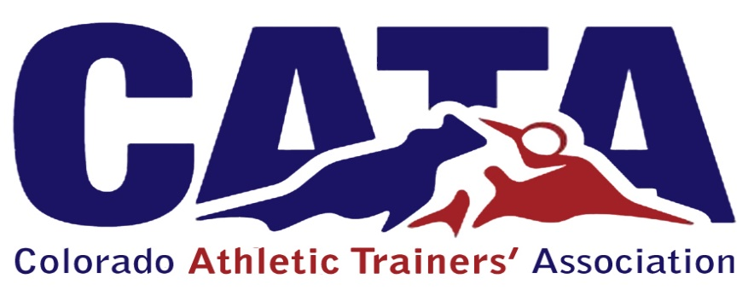

Governmental Affairs Committee
Chair: as appointed
Members: as many deemed necessary
    - The purpose, objectives, and functions of the Governmental Affairs Committee shall be:
      - Maintaining the CATA presence with the Colorado Legislature and increasing the awareness and understanding of certified athletic trainers, and the value which they possess within the legislature.
      - Will be responsible for the conducting an annual “Hill day” at the capitol.
      - The Governmental Affairs Committee chair, along with the President, will communicate with the lobbyist regarding the monitoring of possible bills of interest and take action when necessary.
      - The Governmental Affairs Committee chair will work in conjunction with the district and national office, acting as a state representative to this committee.
      - The Governmental Affairs Committee will submit periodic progress reports to their appointed member at large to be reviewed during the Board of Directors meetings.

TERMS:
1. Chair: 4 years
2. Member: 3 years

